

Name : Chooi Siok Lai

Login ID : R03412902@oasis-portal.my

Course title : Executive Diploma in Culinary Arts & Hospitality Management

Subject Code : CA03 International Cuisine

Submitted date: **07/September/ 2017**

**Table of Contents**

|  |  |  |
| --- | --- | --- |
| **No** | **Details** | **Page** |
| 1 | Executive Summary | 2 |
| 2 | Introduction | 3-5 |
| 3 | Assignment Question |  |
|  | Part 1 | 6-8 |
|  | Part 2 | 9-11 |
|  | Part 3 | 12-14 |
| 4 | Conclusion | 15 |
| 5 | References | 16 |

**Executive Summary**

In this assignment, we will learn about the purpose of this unit that is to be able to understand International Cuisine within Culinary Arts and Hospitality Management.

We will need to choose one dish from each cuisine. The cuisines are Chinese, Indian and Western. From each cuisine, we will need to recreate or alter the original recipe into our own recipe.

For this assignment, I learn many different cutting skill, for example is julienne cut, batonnet and paysanne cut in Chinese cuisine. Indian cuisine is encompasses a wide variety of religion and traditional cuisines native to India. Indian food is very spicy and taste is heavy like tandoori chicken, biryani, and matter paneer and other. Western cuisine is a general term collectively referring to the cuisines of Europe. The main features of western food is prominent materials, beautiful shape, taste delicious, nutrient-rich and easy to supply.

**Introduction**

International cuisine is a cuisine that is practiced around the world. A cuisine is a characteristic style of cooking practices and traditions, often associated with a specific region, country or culture. To become an international cuisine, a local, regional or national cuisine must spread around the world, its food served worldwide. There have been significant improvements and advances during the last century in food preservation, storage, shipping and production, and today many countries, cities and regions have access to their traditional cuisines and many other international cuisines.

**For Vietnam**

-Pho

-Cha ca

-Banh xeo

-Cao lau

-Rau muong

-Nem ran/ cha gio

-Goi cuon

-Bun bo Hue

-Banh khot

-Ga tan

**For Italy**

-Caprese salad with Pesto sauce

-Panzenella

-Bruschetta

-Focaccia bread

-Pasta carbonara

-Margherita pizza

-Mushroom risotto

-Pasta Con Pomodoro E Basilico

-Tiramisu- The ‘pick-me-up’cake

-Panna Cotta with Raspberry Coulis

**For Spanish**

-Croquettes

-Tortilla Espanola

-Gazpacho or salmorejo

-Pisto – Spanish ratatouille

-Cures meats- jamon, chorizo, salchihon

-Pulpo a la gallega

-Spain’s famous bean stews

-Paella

-Fried milk

-Prawns in fried garlic

**For Japan**

-Sushi

-Ramen

-Unagi

-Tempura

-Kaiseki

-Soba

-Shabu-shabu

-Okonomiyaki

-Tonkatsu

-Yakitori

**For Korea**

-Chili pickled cabbage

-Samgyeopsal

-Pork Bulgogi

-Korean Barbecue

-Hangover stew

-Soft tofu stew

-Mixed seafood stew

-Kimchi stew

-Fish stew

-Spicy stir fried octopus

**Assignment Questions**

You should create your own dish from each international cuisine listed.

Required:

Choose one dish for each cuisine:

(i) Chinese cuisine

(ii) Indian Cuisine

(iii) Western Cuisine

1. **Chinese cuisine- Fried Sin Chew Bee Hoon**

**Ingredients ( 2 servings)**

* ½ packet rice vermicelli-bee hoon
* 10 prawns-peeled and deveined
* 2 eggs
* 4 cloves garlic-chopped
* 2 shallots-peeled and sliced
* 1 piece char siew (shredded)
* ½ onion (chopped)
* Handful of beansprouts
* 1 fresh red chilli (I replace with red capsicum)-shredded
* 1 stalk green onions –cut into 3 cm length
* ½ to 1 cup chicken stock
* Cooking oil

**Seasonings**

* 1 rice bowl
* 1 tbsp oyster sauce
* 2 tbsp light soy sauce
* 1 tsp dark soy sauce
* 1 tsp sesame oil
* A dash of pepper

**Method**

1. Soak rice vermicelli in slightly hot water till soften. Drain and set aside.
2. Heat up cooking oil in work. When oil is hot, add eggs, let it set a bit and do a slight scramble. Remove eggs and set aside.
3. Add more oil, fry beansprout, green onion and capsicum over high heat for a while till ingredients are crisp. Remove and set aside.
4. Fry prawns and char siew for a while. Set aside.
5. Add more oil, fry onion, shallots and garlic till aromatic, add rice vermicelli and toss to mix well. Drizzle seasoning and stir fry over high heat. Add stock and let it cook a while.
6. Add in all other ingredients and toss to mix well.
7. Transfer to serving plates and serve with some pickled green chilli.

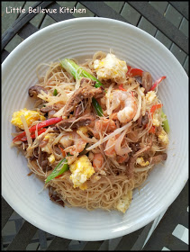

**My own Chinese cuisine recipe-Fried Bee Hoon**

**Ingredient**

* 1 packet Bee Hoon
* 100g bean sprout
* 200g char siew( cut into strip )
* 1 piece fish cake ( cut into strip )
* 3 eggs
* A bit of salt
* Cooking oil

**Method**

* 1. Soak bee hoon for half hour.
  2. Beat 3 eggs, put a little bit of salt.
  3. Heat pan. Add some oil to fry the egg. After fry, take out from the pan.
  4. Put some oil inside the pan. After the oil is hot add fish cake and char siew. After fry for a while, add some water and some salt.
  5. After the water is boil, add the bee hoon. Fry until the water is dry, then add bean sprout and the egg.

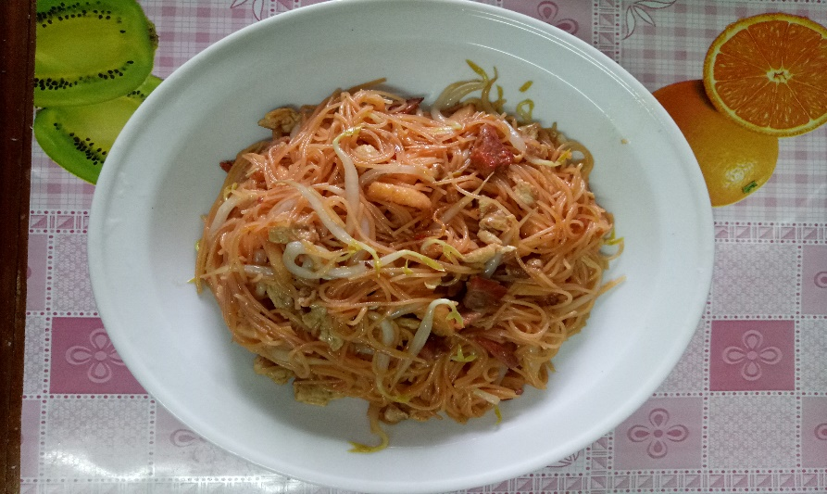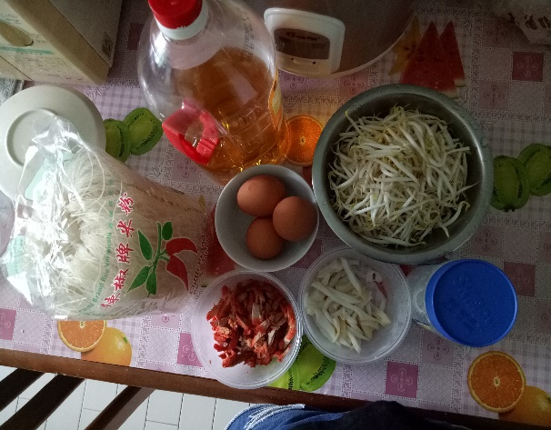

1. **Indian Cuisine- Aloo Gobi**

**Ingredient**

* ¾ cup cubeb potato/ aloo ( ¾ by ¾ inch 1 medium )
* 1 ½ cup gobi / cauliflower florets (150 grams )
* 2 tbsps oil
* ½ tsp cumin / jeera
* 1 cup cubeb onion
* 1 green chili
* ¾ cup deseeded cubeb tomatoes
* 1 tsp ginger garlic paste
* 6 to 8 cashews or 2 to 3 tbsps cream / malai
* ¾ tsp garam masala
* ¾ tsp coriander powder
* ¾ tsp red chili powder ( Kashmiri or byadgi )
* Salt as needed
* ½ tsp crushed kasuri methi / fenugreek leaves
* Coriander leaves handful chopped

**Method**

1. Cut and rinse cauliflower florets well in water. Add them to hot water and set aside for a while. Drain the water.
2. Steam or cook potatoes and cauliflower until half cooked. I usually steam them in a pressure cooker. Bring 2 cups water to a boil in a cooker or steamer. Add the cubeb aloo gobi to a steam basket and steam them until half done. Set these aside. For a restaurant style, you can skip steaming and shallow fry these until half cooked and aromatic. Set these aside.
3. Make a paste of onions. Set aside. In the same jar blend tomatoes and cashews to a fine paste. You can also blend onions, tomatoes and cashews together if you are short of time. But sauntering them separately yields a better tasting gravy in this recipe.
4. Heat a pan with oil, add cumin and allow to splutter. Add ginger garlic paste and saute until the raw smell goes off. Add the onion paste and cook until the paste turns light golden and the raw smell goes away. Add tomato paste and cook until masala turns thick and evaporates all the moisture.
5. Add red chili powder, garam masala, turmeric and salt.
6. Cook until the masala begins to leave the sides of the pan.
7. Then add 1 ¼ cup water and stir well. Cook until the gravy thickens slightly.
8. Add the steamed or fried aloo gobi to the gravy. Cover and simmer until the veggies are cooked completely. Add kasuri meti. Switch off. Add coriander leaves.
9. Serve with rice or roti.

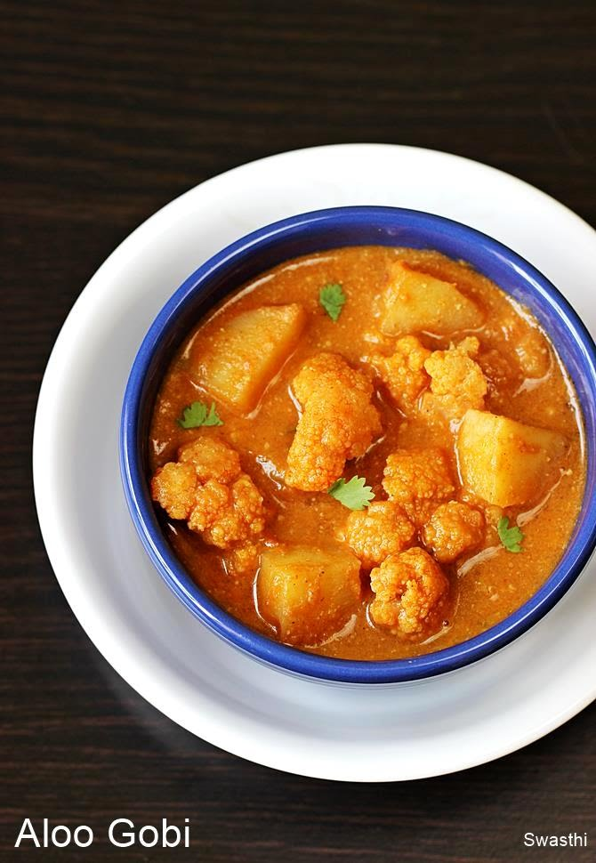

**My own Indian cuisine recipe- Aloo Gobi**

**Ingredient**

* 1 medium potato
* 3 cup cauliflower
* 1 onion chopped
* ½ tsp ginger chopped
* 1 tsp garlic chopped
* 2 tomatoes chopped
* ½ tsp mixed spices
* 1 ½ tbsps of mix curry powder
* 2 tbsps of chopper coriander leaves
* Salt to taste

**Method**

1. Heat 2 tbsps of oil, add the mix spices when it sizzles. Add the chopped onion, ginger, garlic and saute until onions turn golden brown. Add salt to taste.
2. Than add tomatoes ( chopped ) and curry powder, low the flame cook until the tomatoes oil out. Stir a few times in between. You can see the colour differences.
3. Now add the steamed cauliflower and potatoes and add a bit of water and mix with the masala.
4. Cook and simmer for 6-7 minutes. Than add cream and coriander leaves.
5. Serve hot with parathas or chapathi.

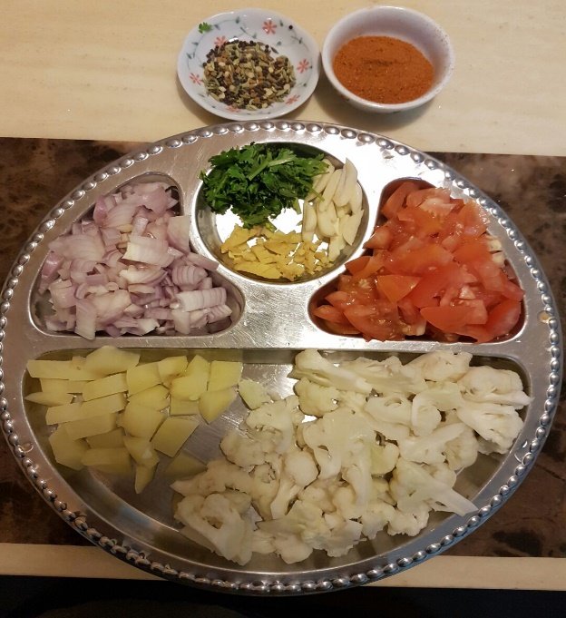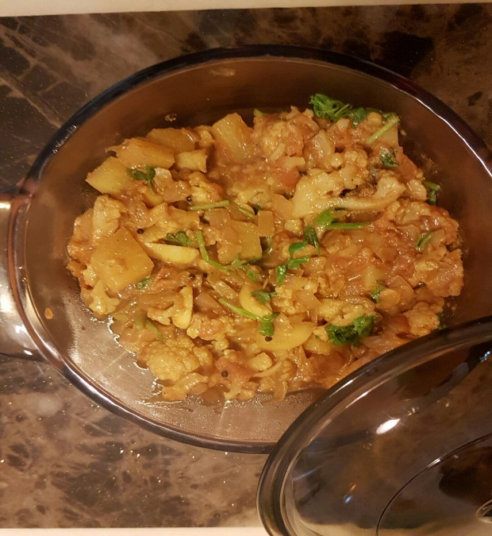

1. **Western cuisine- Gennaro’s classic spaghetti carbonara**

**Ingredients**

* 3 large free-range egg yolks
* 40g Parmesan cheese, plus extra to serve
* 1x150g piece of higher-welfare pancetta
* 200g dried spaghetti
* 1 clove of garlic
* Extra virgin olive oil

**Method**

* 1. Put the egg yolk into a bowl, finely grate in the Parmesan, season with pepper, then mix well with a fork and put to one side.
  2. Cut any hard skin off the pancetta and set side, then chop the meat.
  3. Cook the spaghetti in a large pan of boiling salted water until al dente.
  4. Meanwhile, rub the pancetta skin, if you have any, all over the base of a medium frying pan (this will add fantastic flavor, or use 1 tablespoon of oil instead), then place over a medium-high heat.
  5. Peel the garlic, then crush with the palm of your hand, add it to the pan and leave it to flavor the fat for 1 minute. Stir in the pancetta, then cook for 4 minutes, or until it starts to crisp up.
  6. Pick out and discard the garlic from the pan, then, reserving some of the cooking water, drain and add the really soaks up all that lovely flavour, then remove the pan from the heat.
  7. Add a splash of the cooking water and toss well, season with pepper, then poer in the egg mixture-the pan will help to cook the egg gently, rather than scrambling it. Toss well, adding more cooking water until it’s lovely and glossy.
  8. Serve with a grating of Parmesan and an extra twist of pepper.

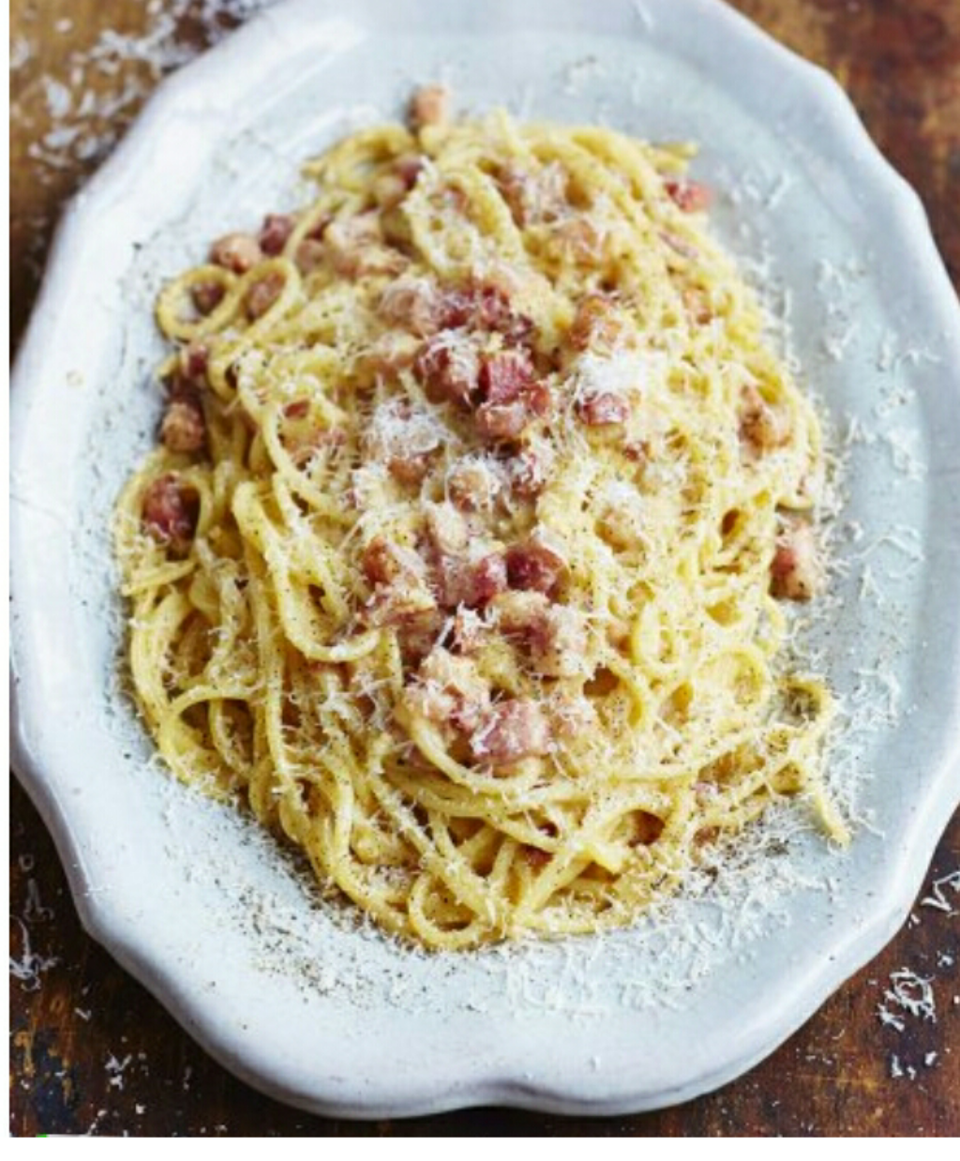

**My own western cuisine recipe-Tomato spaghetti**

**Ingredient**

* ½ dried spaghetti
* ½ cherry tomato
* ½ corn
* ½ mushroom
* 2 tspn salt
* A bottle tomato pasta sauce

**Method**

1. Put the water and spaghetti together and cook until the water boiling.
2. When the spaghetti is cook well, and then pour the water, the spaghetti put into the basin.
3. After than the cherry tomato, corn and mushrooms into the water hot. After the hot, all put into the bowl.
4. Put the tomato pasta sauce into the pot cook and put salt, after stir evenly.
5. So put the cherry tomato, corn, mushroom and spaghetti into the tomato sauce. Stirevenly it is ok.

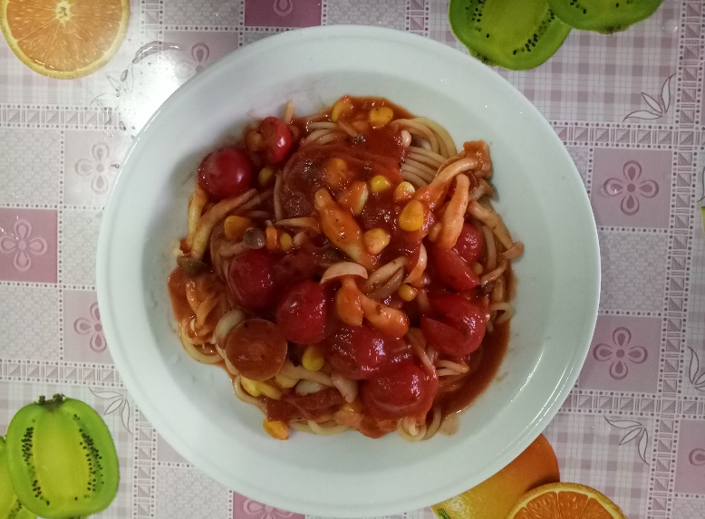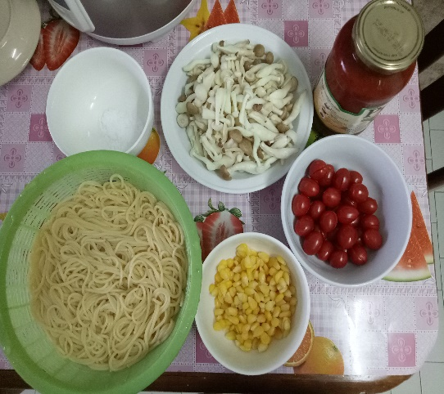

**Conclusion**

For this assignment, I learn about the purpose of this unit that is to be able to understand International Cuisine within Culinary Arts and Hospitality Management. International cuisine is a characteristic style of cooking practices and traditions, often associated with a specific region, country or culture. To become an international cuisine, a local, regional or national cuisine must spread around the world, its food served worldwide.

Why having International Cuisine is good? This is so, we can understand the traditional culture and customs of other countries through food, and also we can taste the food from other countries. And other countries can also come to Malaysia to do business to promote their dishes. Food is different around the world because latitude, weather, soil differ, patterns of economic organization, trade and travel differed. All of the above factors caused differences in available plants and animals as food, differences in fuel and cooking styles, and differences in tastes and preferences.

**References**

Unknown, July 15 2015, Online source, Fried Sin Chew Bee Hoon, <http://littlebellevuekitchen.blogspot.sg/2015/07/fried-sin-chew-bee-hoon.html?m=1>

Swasthi, September 02 2017, Online source, Aloo Gobi <http://indianhealthyrecipes.com/aloo-gobi-recipe/>

Jamie, unknown, Online source, Gennaro’s classic spaghetti carbonara <http://www.jamieoliver.com/recipes/pasta-recipes/gennaro-s-classic-spaghetti-carconara/>